**Bytewise Fellowship Task # 2**

* Write a query to get data having length of rna structures more than 12 with them being added after 2008.

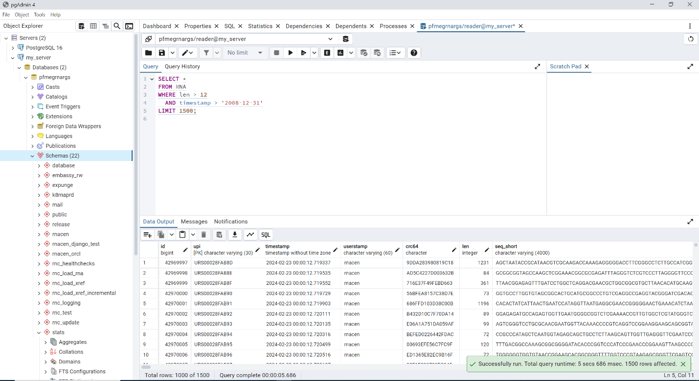

* How many pre computed RNA are present that are still active and got their last release update before 2022?

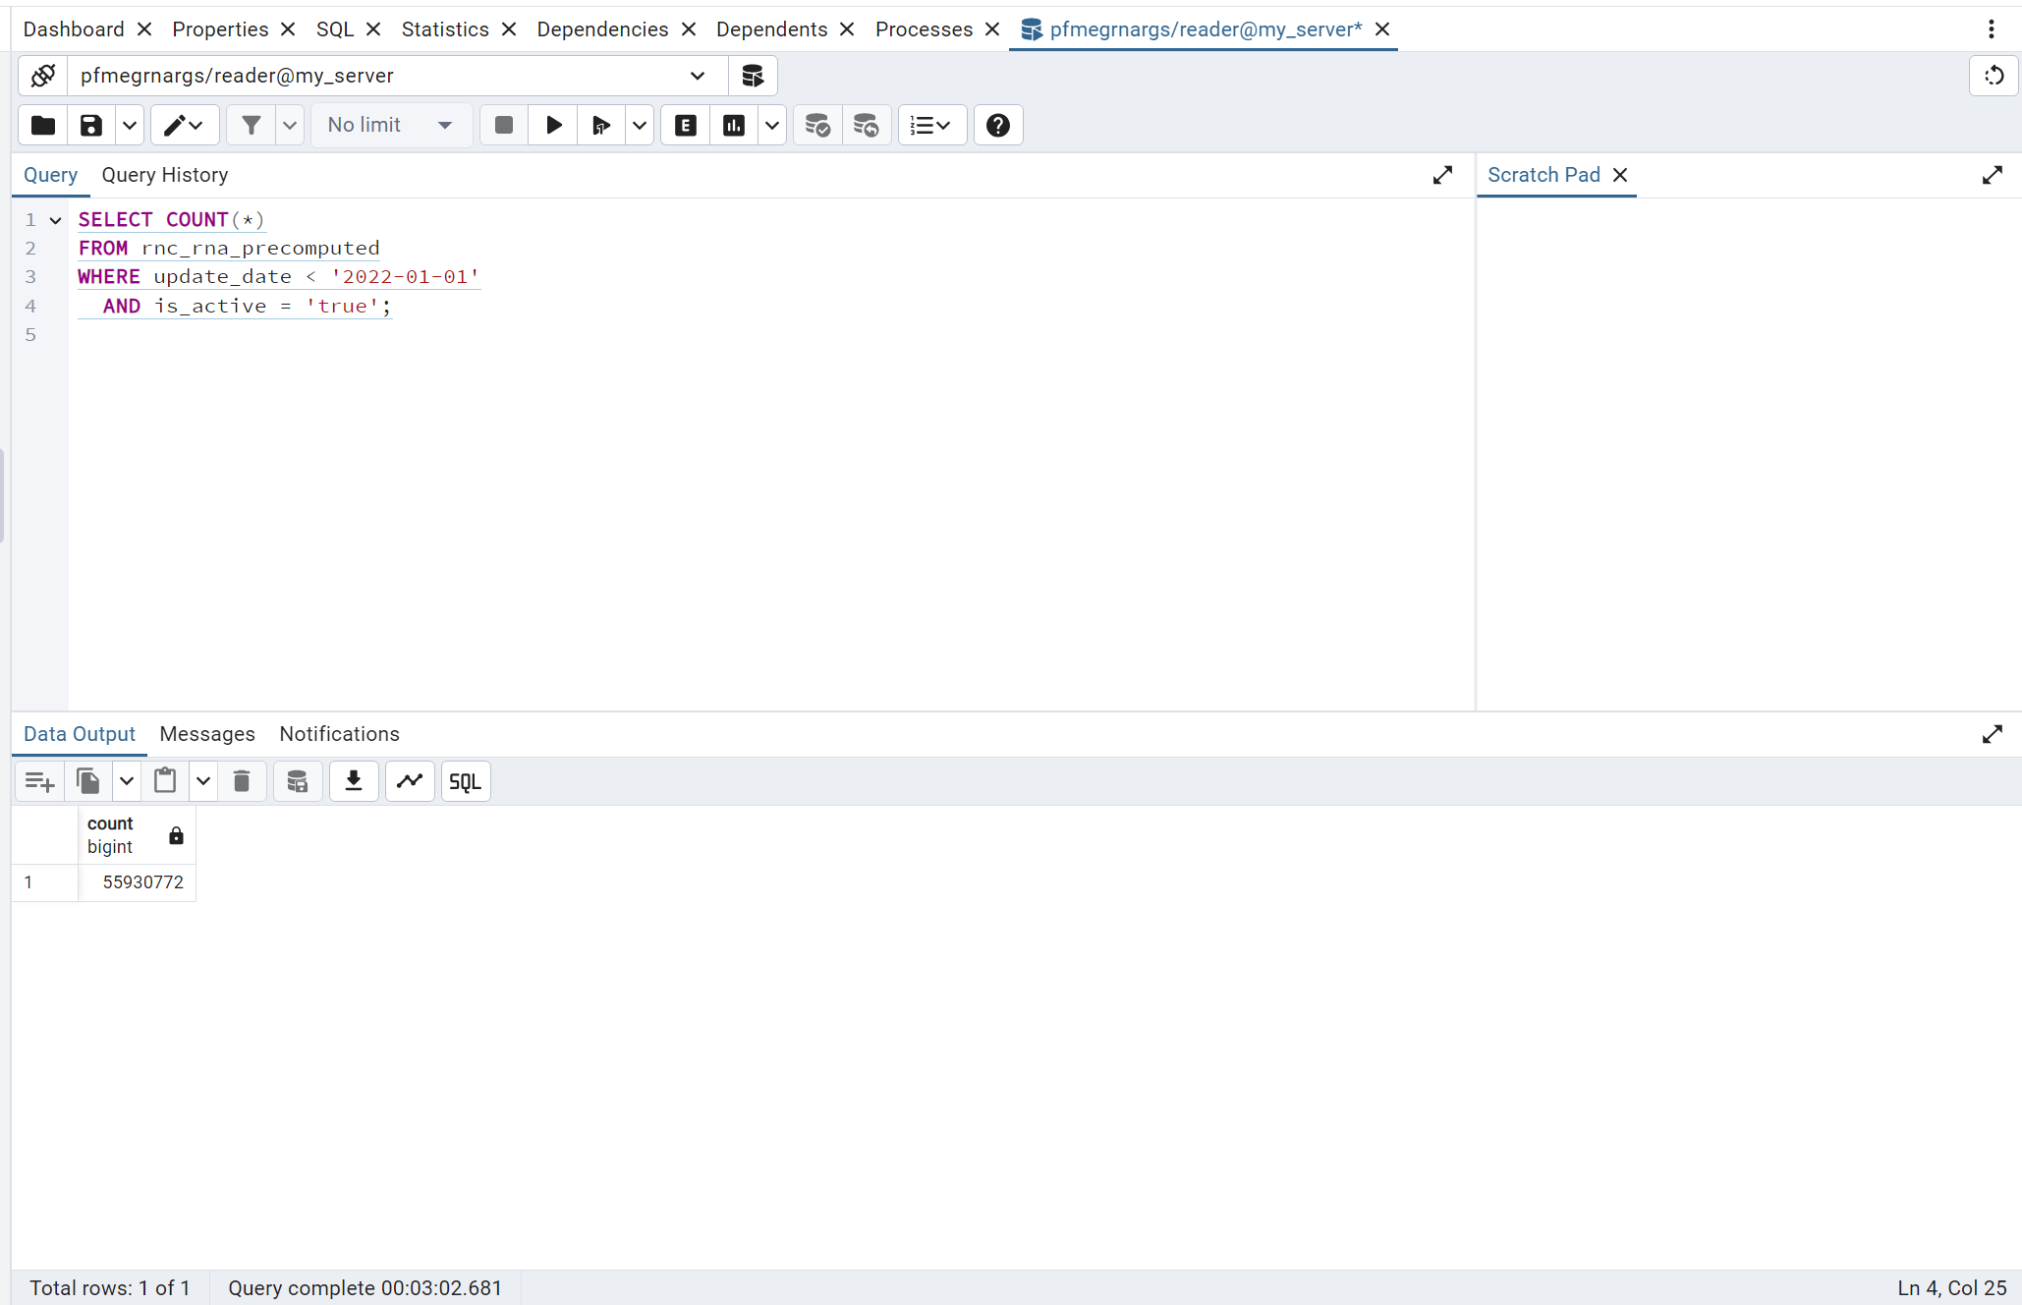

* Can you give me the names of all databases built for RNA with minimum length other than 100, 200, 300, 400, and 15?

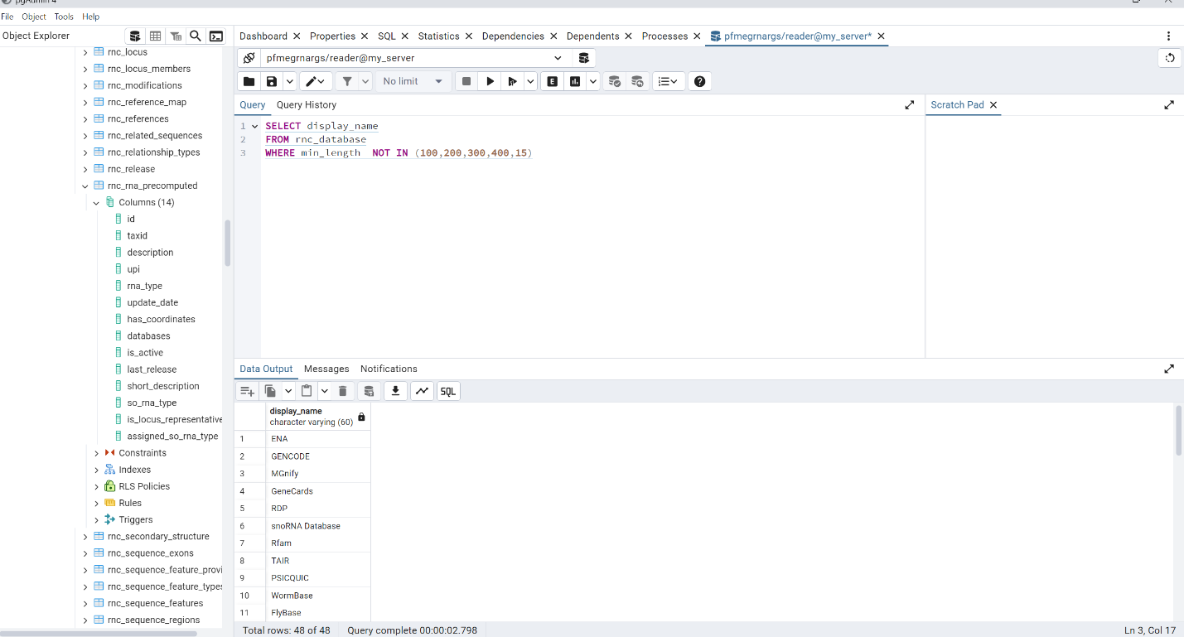

* Can you get complete 500 records of sequences for active regions and name your column as myregions in which you are getting the region name column value. Then tell me what different chromosomes with exon count we have for regions including center, east and northusing the name you set for your column?

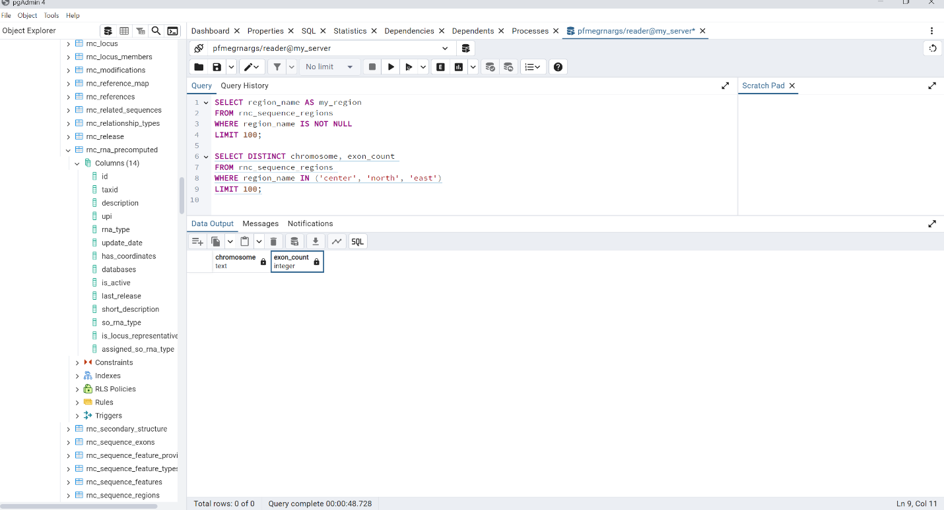

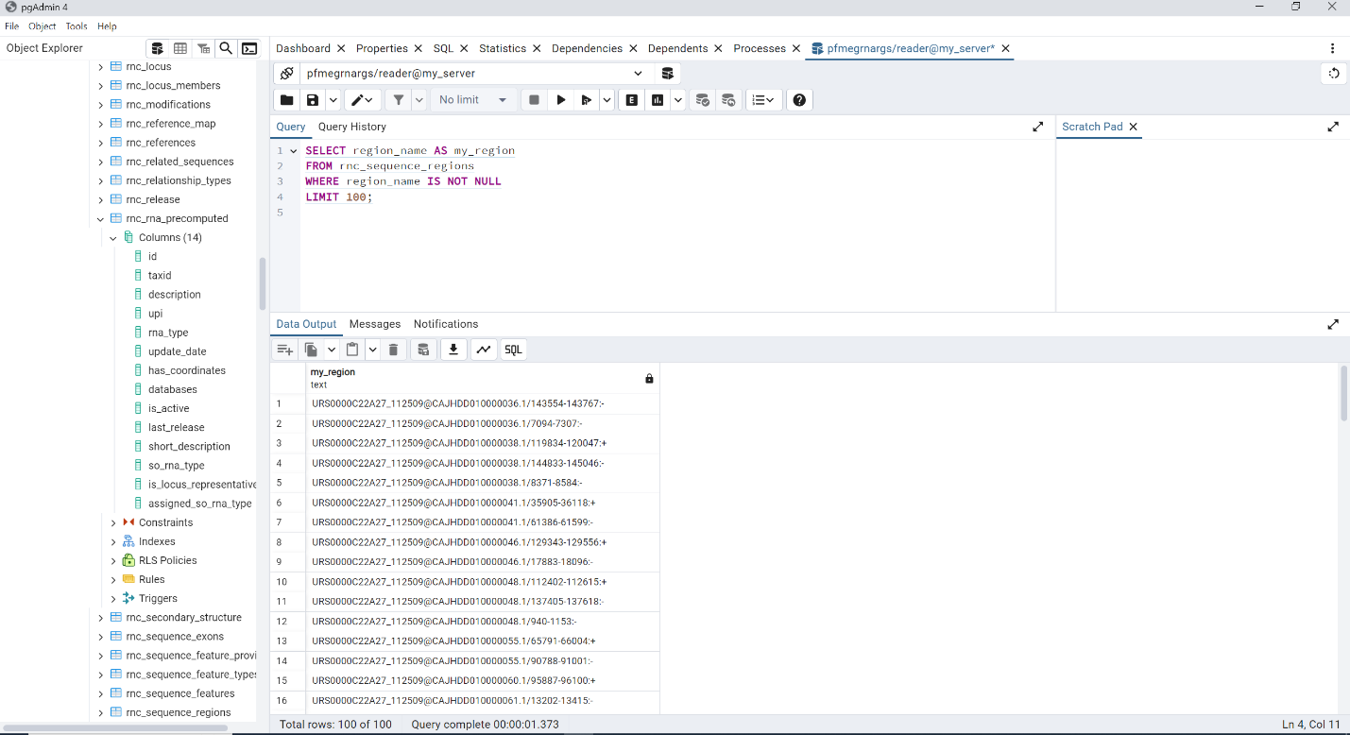

* How many total pre computed RNA records for snoRNA and tRNA were recorded in 2011, 2016, 2014, and 2020?

